**SWIFT Field Tag = 56A:**

Two Conditions:

1. Payment currency does not match the local currency of the country where the beneficiary bank is located. Exception: Some countries accept more than one currency. If payment is in an accepted currency of the country, then intermediary bank is not needed. **Refer to Exception Countries in Chainlink - SVB_Global_Wire_Payments_MT103_Specs PDF**.

OR

1. Intermediary Bank Information should be excluded from USD payments.

**SWIFT Field Tag = 57A:**

1. SWIFT BIC (8- or 11-character Bank Identifier Code)
2. **Refer to Table 2: Country-Specific Requirements in Chainlink - SVB_Global_Wire_Payments_MT103_Specs PDF**

**Test Cases:**

1. In Payment File Administration = 00000027 File, Currency is GBP and Country Code being ES. As per the table of exception countries, Es country code is not defined for GBP currency. **So 56A (Intermediary Bank) field and 57A (Beneficiary Bank) field is Appear in Wire Payment File**.

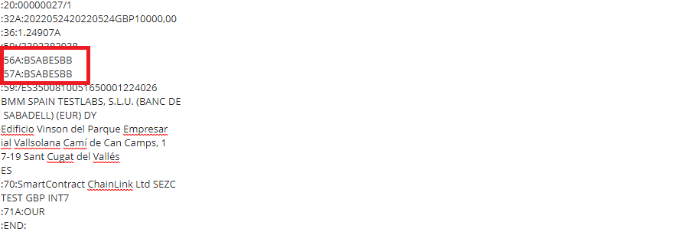

1. In Payment File Administration = 00000027 File, Currency is EUR and Country Code being GB. As per the table of exception countries, GB country code is defined for EUR currency. **So Intermediary Bank 56A field is Not Appear in Wire Payment File. Only 57A (Beneficiary Bank) field is Appear**.

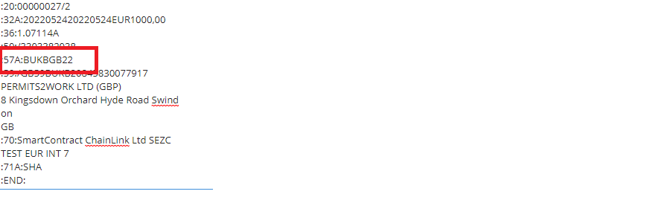

1. In Payment File Administration = 00000002 File, Currency is USD. As per the table of **Country-Specific Requirements in Chainlink - SVB_Global_Wire_Payments_MT103_Specs PDF,** Intermediary Bank Information should be excluded from USD payments. **So Intermediary Bank 56A field is Not Appear in Wire Payment File. Only 57A (Beneficiary Bank) field is Appear**.

